Query the ****NAME**** field for all American cities in the ****CITY**** table with populations larger than 120000. The CountryCode for America is USA.

The ****CITY**** table is described as follows:

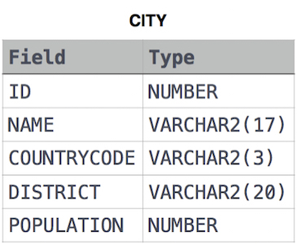

SELECT name FROM city

where countrycode = 'USA' and population > 120000;